**Oversight and Compliance**

**Training Manual**

|  |  |
| --- | --- |
| **Target Group** | *The training is designed for a mixed group of participants. Ideally, there should be representatives of different party levels, bodies, and structures such as:*   * *Top party leadership* * *Regional and local branches* * *Existing bodies with an oversight role* * *Youth and Women forums* * *Elected officials* * *Executive Board* |
| **The rationale for the training topic** | *Political parties in Western Balkans lack effective oversight and compliance mechanisms. Also, even when there are formally established mechanisms, often these are not fully enforced. Therefore, parties fail to prevent corruptive and dishonest behavior of party members and elected officials, resulting in the declining trust of citizens in political institutions and processes and frequent political scandals and affairs.*  *To limit political corruption, state regulation needs to be accompanied by effective internal oversight and compliance strategies that political parties need to develop and strongly commit to implementing.* |
| **Learning objectives** | * *To provide space for participants to identify internal deficits and gaps that would make political corruption and unethical behavior possible;* * *To support participants to respond to identify deficits and gaps by drafting possible oversight and compliance mechanisms that could be effectively applied in the party and* * *To allow participants to discuss strategies for encouraging the party's key decision-makers to commit to taking action to address oversight and compliance gaps.* |
| **Structure for the training** | *Ideally, there will be 15 to 20 participants in total.*  *Resources needed: Board or flipchart and markers, masking tape, colored stickers, computer projector If available, refreshments* |
| **Follow-up plan** | *Possible follow-up activities could include the finalization of drafted oversight and compliance mechanisms. E.g. writing the party's Codes of Conduct, designing the Oversight Committee rulebook, creating whistleblowing procedures, etc.* |

***AGENDA***

*Oversight and Compliance*

|  |  |  |
| --- | --- | --- |
| **Time** | **Agenda Item** | **Resources** |
| 20 min | **Introduction and expectations** | Lead trainer |
| 45 min | **Understanding internal and external deficits that lead to political corruption**   * Presentation: 15 minutes * Brainstorming: 30 minutes | Flip Chart  Markers and masking tape |
| 75 min | **Ensuring the party's commitment to preventing misconduct and complying with external requirements and regulations**   * Presentation: 15 minutes * Work in small groups: 30 minutes * Presentations and facilitated group discussions: 30 minutes | PPT presentation  Flip Chart  Markers and masking tape |
| 30 min | **Coffee Break** | Refreshments |
| 90 min | **Setting up internal party mechanisms for oversight and compliance**   * Presentation: 15 minutes * Work in small groups: 56 minutes * Presentations and facilitated group discussions: 30 minutes | PPT presentation  Flip Chart  Stickers  Markers and masking tape |
| 20 min | **Conclusions and way forward** |  |

**Session 1: Introduction and expectations**

The trainer welcomes the participants and presents the overall structure of the workshop and the main objectives of the workshop. The objectives as stated in the introduction part of the training manual should be shared and discussed with the participants.

After the official welcome and opening of the course, the trainer sets up an icebreaking session to engage the group dynamics. Each participant will be asked to present him/herself and to state one value of his/her party that relates to the party's integrity.

**Session 2: Understanding internal and external deficits that lead to political corruption**

Political parties are often seen as a fruitful ground for corruption – abusing power and positions in the public sector, manipulating public resources, extorting bribes, demonstrating 'creativity' in dealing with campaign money… Wherever power provides an access to various resources, corrupted individuals will see an opportunity for themselves. Parties without effective internal safeguards will be particularly exposed to political corruption.

Training Activity 1: Brainstorming (30 minutes)

1. Begin the discussion by asking how many participants have recently heard of examples of political corruption in the region.

2. Ask participants to briefly describe examples they are aware of.

3. Facilitate the discussion, encouraging participants to explain their understanding of the failings in the legislation and/or in internal parties' set-up that allowed the corruptive behavior of politicians and elected officials. Ask participants if their party also faces such internal weak points/deficits.

4. When no new ideas are brought up, summarize the discussion by presenting the list of weak points / black spots in the legislation and/or in the internal parties' set-up that allowed political corruption.

Political parties and politicians face a critical question today across the globe – How to prevent political scandals and affairs to occur and how? How to eliminate dishonest individuals and prevent misconduct? What measures should be taken to curb possible party corruption?

At the same time, it is true that even with the best intentions, all people make mistakes and any political party needs some controls to minimize the effects of unintentional mistakes.

On the one hand, there is internal demand to bring back citizens' trust and on the other hand, there is public pressure for increased efforts to struggle against political corruption.

There is a variety of state mechanisms to ensure external oversight - state bodies (e.g. Ministry of Justice), independent commissions, courts, or even anti-corruption agencies. Also, oversight is by civil society organizations and media.

However, a key question here is what forms of self-regulation, anti-corruption measures, strategies, and internal control mechanisms, political parties can apply to promote their integrity and eliminate any form of corruptive behavior.

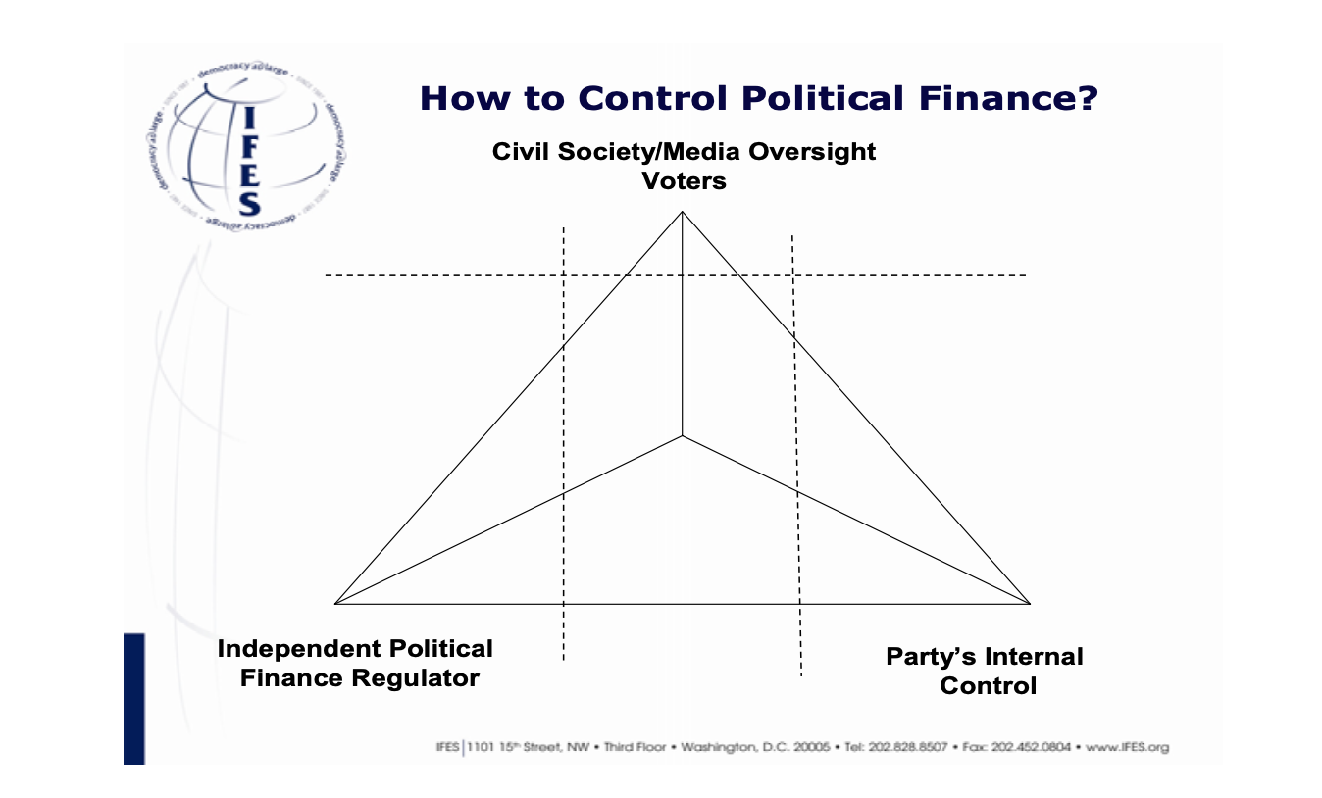

**Session 3: Ensuring the party’s commitment to preventing misconduct and complying with external requirements and regulations**

One of the main points related to institutionalizing Internal Control Mechanisms is how to encourage party leaders to demonstrate a strong commitment to these processes.

Training Activity 2: Work in Small Groups

Step 1: Directions and group work (30 minutes)

1. Divide participants into small groups of up to four people. Ask each small group to assign a reporter.

2. Tell the groups to discuss and make a list of the most important challenges/limitations for establishing effective internal oversight and compliance mechanisms in the party and possible mitigation strategies.

Step 2: Group reports and summary (30 minutes)

3. In plenary ask reporters to present their group’s findings, going through the identified challenges and responses one by one. Make sure the reporters take turns. Note down the findings of each group on the flipchart.

4. Confirm and/or clarify responses, filling gaps if necessary.

5. Summarize the main outcomes of the discussion by clustering similar challenges and responses and conclude by asking: Which strategies do you believe will work the best?

In his book titled ‘The Cost of Democracy’ (Oxford: Hart Publishing 2007), Keith D. Ewing claims ‘there are at least three serious problems suggesting that internal control is unlikely to be enough on its own. Firstly, what one political group has agreed to be bound by will not necessarily be matched by the others. Secondly, the way these rules and procedures are practically applied will be determined by the parties themselves; so a party can take a narrow view of what the rules are. Finally, what would be the sanctions for breach of the rules voluntarily adopted and who is to enforce them? Thus, internal oversight should be perceived as a precursor to and a companion of State regulation' (Regulating Politics: The role of internal and external oversight in Europe - Dr. Marcin Waleck).

**Session 4: Setting up internal party mechanisms for oversight and compliance**

There are many strategies applied by political parties globally, seeking to ensure effective oversight and compliance. Such strategies include the introduction of codes of conduct for party members, designing and applying specific internal party financial checks and balances, appointing specific officials or separate bodies — "compliance agents" who take care that party's actions comply with legal restrictions and state legislation and oversee compliance with party internal disciplinary codes and codes of conduct (e.g. oversight committees, internal audits etc.) creating and implementing measures to strengthening internal party democracy (e.g. involving rank and file members should in the elections of party leaders), increasing transparency and accountability within a party (e.g. Disclosure of income, assets, and other information useful for the prevention of corruption), creating working whistleblowing system in a party, allowing members to report corruption and misbehavior, providing an ambient where various party fractions can perform oversight and thus limit the opportunities for political corruption. All these strategies are context-sensitive. Political parties should avoid simply copying–pasting them from other countries and regions. Instead, parties need to put efforts to rethink possible alternatives and designing such mechanisms that will meet their needs and fit into the existing context.

Training Activity 3: Small Groups Work - Designing Effective Internal Oversight and Compliance Mechanisms

Step 1: Directions and group work (45 minutes)

1. Divide participants into groups. Ask each group to appoint a facilitator and a reporter.

2. Distribute stickers to each group.

3. Groups discuss and suggest concrete, practical and realistic oversight and compliance mechanisms that meet identified challenges (minimum three for each). A reporter writes one suggestion on each sticker

Step 2: Reporting and summary (30 minutes)

4. Each group reporter presents the stickers to the plenary, giving a detailed explanation if required. Cluster the stickers on the board or wall according to themes/ideas.

5. Seek consensus on the three mechanisms that could be effectively applied in the party.

**Session 5: Conclusions and Follow-up**

Conclude the training by launching and facilitating discussion on possible follow-up. Divide participants into groups and task them to continue working on one of three oversight and compliance mechanisms that were identified during the previous training activity.